Exception Handling:
What is Exception? An Exception can be defined as the unusual occurrences of something that may cause the abnormal termination of the program.
An Exception is caused due to some runtime errors, and if not handled the program gets terminated.
By means of exception handling routines we can avoid or handle the errors in our program and can write better solution.
SEH = Structured Exception Handling

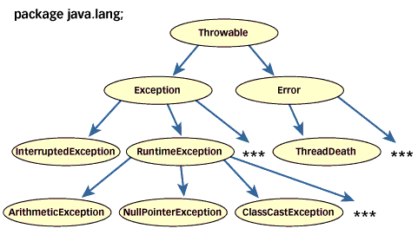

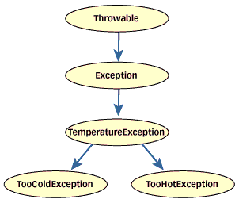
Exception Class: Exception is the base class for all kind of exception in our program, the throwable class is the base class for exception. All the sub exception or exception types inherits this class to write the new exceptions.

Exception Types
1. Arithmetic Exception
2. ArrayException
3. I/O Exception
4. JDBC Exception
5. Format Exception
6. Null Pointer Exception

Note: Exception is the base / parent class for all kind of exception
Exception Handling Keywords / Blocks:
Java provides the following important keywords/block for handling the exception
1. try - it is used to monitor the code where there is any possibility of error, in case of error it throws an exception object of the error / exception type, this exception object is caught in the suitable catch block.
* Every try must have at least one catch block or finally block, although a try can have one or more catch block
* try can also be nested,
try
{

}
catch(Exception e)
{
}
2. catch - it is used the catch the exception raised in the try block, here we can print the suitable error messages,
* the printStackTrace() will display the error in details.
3. finally - this is an optional block , it executes in all the conditions where there is any error or no error, it generally used for the clean-up task such as closing the file, database connection etc. this is only used to complement the try block but will not handle the error.

4. throw - it is used to explicitly throw the exception or error, it is useful in case of custom exception / user defined exception
5. throws - it is used to report the unhandled exception in your program so that the implementing class or method may perform the necessary exception handling task.

Example without exception handling
class exp01
{
public static void main(String args[])
{
int x = Integer.parseInt(args[0]);
System.out.println("x="+x);
}
}
Example with Exception Handling
class exp01
{
public static void main(String args[])
{
try
{
int x = Integer.parseInt(args[0]);
System.out.println("x="+x);
}
catch(Exception ex)
{
System.out.println(ex);
}
System.out.println("done!");
}
}
Example :
import java.util.*;
class exp01
{
public static void main(String args[])
{

int a=0;
while(a<5)
{
try
{
Scanner obj = new Scanner(System.in);
System.out.print("Enter x : ");
String s = obj.nextLine();
int x = Integer.parseInt(s);
System.out.println("x="+x);
}
catch(Exception ex)
{
System.out.println(ex);
}

a++;
}
System.out.println("done!");
}
}

Example of finally
class exp01
{
public static void main(String args[])
{

try
{
int x = Integer.parseInt(args[0]);
System.out.println("x="+x);
}
finally
{
System.out.println("done!");
}
}
}
Checked vs Unchecked Exceptions
Type of exceptions in java are checked exceptions and unchecked exceptions. This classification is based on compile-time checking of exceptions. There is also a classification based on runtime in java. It is not widely known! That is synchronous and asynchronous exceptions. First let us see the java checked exceptions and unchecked exceptions.
Checked Exceptions Vs Unchecked Exceptions in Java
At compile time, the java compiler checks that a program contains handlers for checked exceptions. Java compiler analyzes by which checked exceptions can result from execution of a method or constructor. For each checked exception which is a possible result, the throws clause for the method or constructor must mention the class or its super classes of that exception.
The class RuntimeException and its subclasses, and the class Error and its subclasses are unchecked exceptions classes. Because the compiler doesn’t forces them to be declared in the throws clause. All the other exception classes that are part of Throwable hierarchy are checked exceptions.
Now let us see a see small discussion on why exceptions are classified as checked exceptions and unchecked exceptions.
Those unchecked exception classes which are the error classes (Error and its subclasses) are exempted from compile-time checking in java because they can occur at many points in the program and recovery from them is difficult or impossible.

